WATER CONTENT
INTRODUCTION:
The water content (w) is also called natural water content or natural moisture content is the ratio of the weight of water to the weight of the solids in a given mass of soil. This ratio is usually expressed as percentage.
In almost all soil tests natural moisture content of the soil is to be determined. The knowledge of the natural moisture content is essential in all studies of soil mechanics. To sight a few, natural moisture content is used in determining the bearing capacity and settlement. The natural moisture content will give an idea of the state of soil in the field.
OBJECTIVE:
This test is done to determine the water content in soil by oven drying method.
THEORY:
For many soils, the water content may be an extremely important index used for establishing the relationship between the way a soil behaves and its properties. The consistency of a fine-grained soil largely depends on its water content. The water content is also used in expressing the phase relationships of air, water, and solids in a given volume of soil.
Soil mass is generally a three phase system. It consists of solid particles, liquid and gas. For all practical purposes, the liquid may be considered to be water (although in some cases, the water may contain some dissolved salts) and the gas as air. The phase system may be expressed in SI units either in terms of mass-volume or weight-volume relationships. The inter relationships of the different phases are important since they help to define the condition or the physical make-up of the soil.

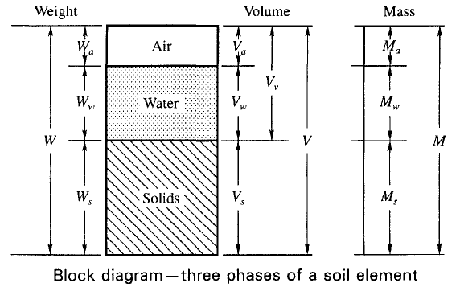

The water of the soil sample can be determined by the following method.
- Oven drying method.
- Pycnometer method.
- Sand bath method.
- Alcohol method.
- Calcium carbide method.
- Radiation method.
- Torsion balance method.
After complete drying the soil sample become,
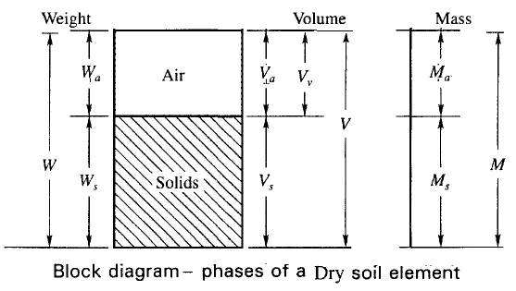
APPRATURS REQUIRED:-
- Non-corrodible air-tight container.
- Electric oven, maintain the temperature between 105 C to 115 C.
- Desiccators
- Balance of sufficient sensitivity
TEST PROCEDURE:-
- Clean the containers with lid dry it and weigh it (W1). " Make sure you do this after you have tarred the balance"
- Take a specimen of the sample in the container and weigh with lid (W2).
- Keep the container in the oven with lid removed. Dry the specimen to constant weight maintaining the temperature between 105⁰ C to 110⁰ C for a period varying with the type of soil but usually 16 to 24 hours.
- Record the final constant weight (W3) of the container with dried soil sample. Peat and other organic soils are to be dried at lower temperature (say 60⁰ C ) possibly for a longer period.
RUNNING THE TEST AND RECORDING THE DATA:-
- Weight of can, W₁ (g) =
- Weight of can + wet soil W₂ (g) =
- Weight of can + dry soil W₃ (g)=
The Water/Moisture content =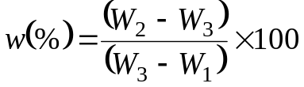

The natural moisture content of the soil sample is _ __%

Example Calculation:
Weight of can, W₁ (g) = 30.5g
Weight of can + wet soil W₂ (g) = 62.6g
Weight of can + dry soil W₃ (g) = 58.2g
The Water/Moisture content =

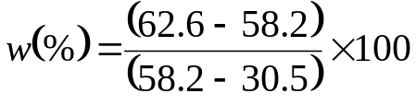

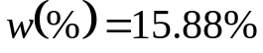

OBSERVATION TABLE:-
 | Type 1 | Type 2 | Type 3 | Type 4
Weight of can, W₁ (g)
Weight of can + wet soil W₂ (g)
Weight of can + dry soil W₃ (g)
Water/Moisture content 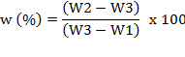

REFERENCE:-
- IS : 2720 (Part II) – 1973, Method of Test for soil : Part II
- Soil Mechanics and Foundations.
QUIZ:
- Which method is mostly used to determine the water content in field?
- What is water content for loss soil?
- On which factor cater content is depends?

